Lesson Goal: To use strategies based on place value and visual models to divide 2- and 3- digit numbers by 1-digit numbers.

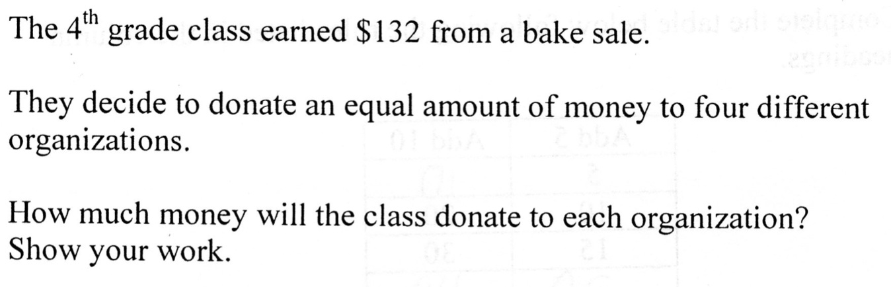
Exit Card
- Solve the task.
- What are the structures of this exit task?
- What errors might students make?
- Why do you think Ms. Ward selected this question?

Using the OGAP Quick Sort
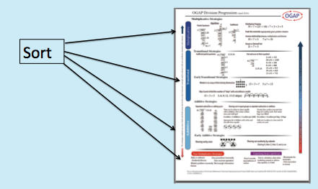

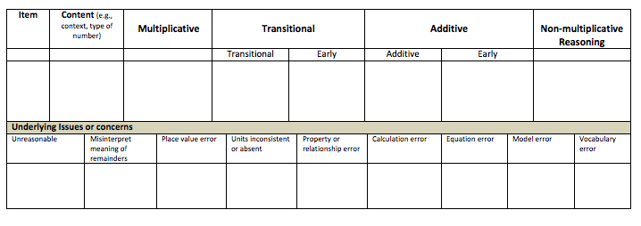
- What is the evidence of developing understanding?
- What issues are evidenced in the student work?
- What should Ms. Ward do to respond to the work instructionally?

After sorting the work Ms. Ward was pleased to see that all the students recognized the task as division and had a variety of informal strategies to find the solution.

Like you, she could see that these students used a sharing out by 1s strategy while the rest of the class had more efficient methods relying on unitizing.

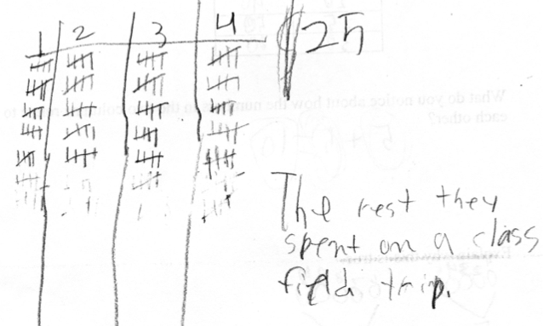
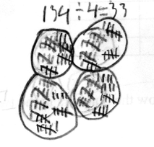
Student J
Student G

Since the lesson for the next day was focused on introducing partial quotients using a menu, she decided to work with these 2 students in a small group while the rest of the class worked on a set of mixed review problems.

Help Ms. Ward

- What do these 2 students understand that can be built upon to move them along the progression?
- What would be your instructional goal for these students?
- Use your knowledge of problem structures to modify the task that could be used to work with these students to move them beyond a sharing out by 1s strategy
- What questions would you ask to help them focus on using a “groups of” strategy to divide?
Modified Task:

Questions:

