Part I: What questions related to multiplication might you ask your students about this picture?

Muffin Tin Figure on Page 40 – Fosnot, K. (2001). CD – Young Mathematicians at Work – Constructing Multiplication and Division, Heinemann, NH.

Part II: Examine the student work in figures 1.6-1.9 and read the quote from NCTM Principles and Standards for School Mathematics (PSSM, 2000). Based on your experience, thinking, and the information mentioned, complete the statement in the box below.

“Multiplicative reasoning is more than just doing multiplication or division. It is about understanding situations in which multiplication or division is an appropriate operation. It involves a way of viewing situations and thinking about them.” (PSSM, 2000)

The student who has multiplicative reasoning demonstrates…

Part III: Watch the video clips and respond to the questions below.

Watch Introduction to Muffin Tins

Clip 1: Take note of questions that Dana asks and her strategies for facilitating students’ discourse.
- What did the teacher do to facilitate the conversation and learning so that students engaged in discourse towards acquiring MR?

- What strategies do the students use that are found on the OGAP Multiplicative Reasoning Framework? What are instructional implications based on the location on the OGAP framework?

- What mathematics do you think she will try to get with the next set of trays?

- What is the teacher doing to facilitate a focus on composite units?

Clip 2

- We have already talked about what the teacher did to facilitate student learning. Are there more observations from this clip?

- Identify some strategies that students used found on the OGAP Multiplicative Reasoning Framework. What are instructional implications based on the location on the OGAP framework?

- What mathematics do you think she will try to get with the next set of trays?

d) What evidence is there that students are struggling with composite units?

Part IV: Assume that you did the Muffin Tin problem with the students in your classroom.

  - What aspects of the question below make it a good choice as a follow-­‐up to the lesson? What concepts were considered when the item was designed?

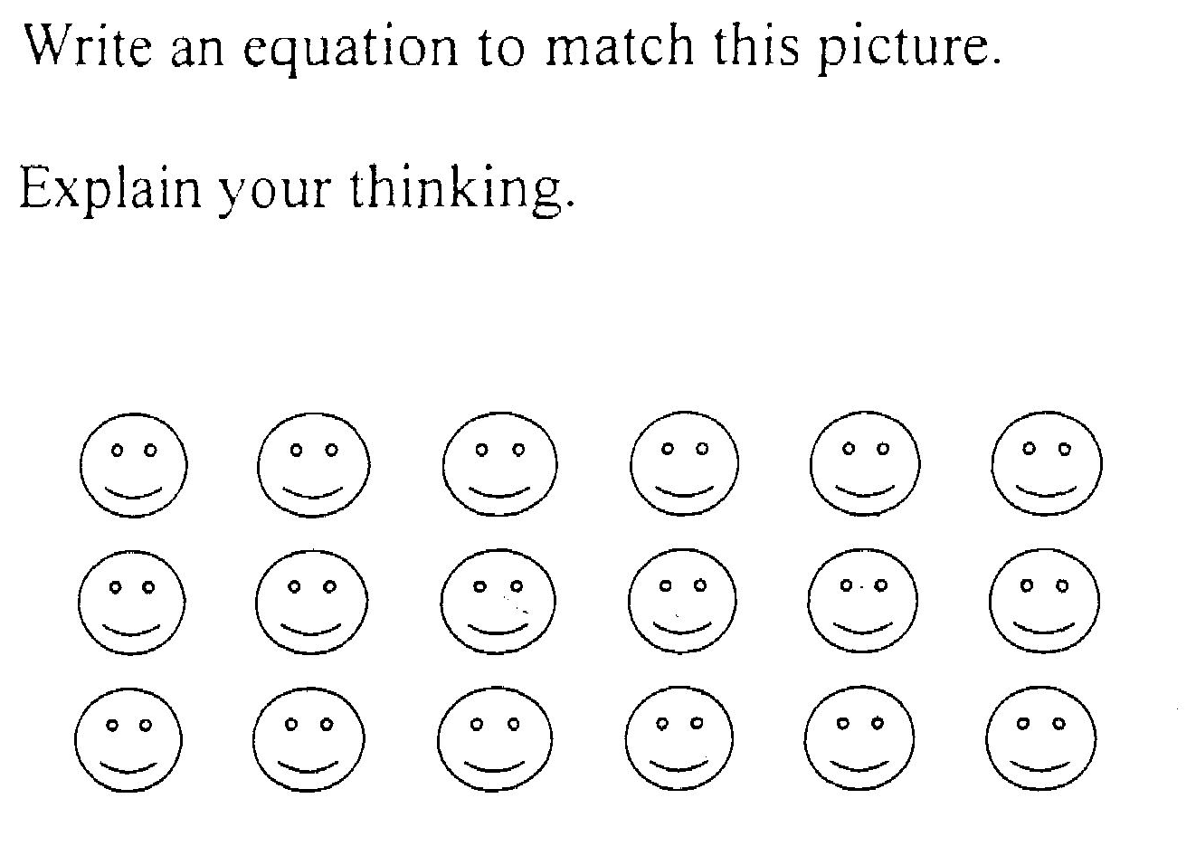

  - With a partner sort the student work in the different strategies that students used (regardless of the correctness of the solution).

  - Identify the location of the different strategies on the OGAP Multiplicative Reasoning Framework. Select one piece of work and indicate possible instructional implications based on the evidence and location of the framework.

